ROYAL OAK INTERNATIONAL SCHOOL
SR. SEC. C.B.S.E. AFFILIATED (2019-20)
WHOLE YEAR SYLLABUS OF CLASS III

SUBJECT-ENGLISH

MONTH | NO. OF WORKING DAYS | CONTENT | ACTIVITY | WORKSHEET
April | 18 | MCB:-  Ch 1 In the classroom  Poem: School  Lit.:-  Ch 1 In the mango grove  Grammar.:- Nouns , Singular/ Plural, Punctuation  Writing:- Picture composition | Categorization of kinds of nouns using slips ask the students to frame sentences.
May | 8 | MCB:  Ch 4 The Elephant Artist (reading)  Lit.:-  Ch 9 Just touch & read |  | - As per syllabus covered
July | 24 | MCB:-  Ch-2 The Proud Little Apple Blossom  Lit.:-  Ch -2 Good Morning Merry Sunshine (poem)  Grammar.:- Gender, Pronouns , Verbs  Writing:-  Paragraph writing “ My Family” | - Act it out (game) | - Revision worksheet  - Recap Test ( M.M- 10 )
Written Evaluation Syllabus :PA I (July) M.M: 30
MCB
CH-1 In the classroom
Ch -2 The Proud Little Apple
Lit.:-
Ch-1 In the mango grove
Ch- 2 Good Morning Merry Sunshine (poem)
*Poem : School
Grammar : Nouns, Pronouns , Singular/ Plural
Writing : Picture Composition
Aug. | 25 | MCB:-  Ch-5 A Busy morning  Ch- 6 Gulliver’s Travel  (reading)  Lit.:-  Ch 3 Alice in Wonderland-I  Ch-4 Alice in Wonderland-II  Grammar.:- Verbs (cont..) Adjectives, Sentences, Articles  Writing:-  Creative writing | - Use flash cards for articles | - As per syllabus covered
Sept. | 4 | MCB.  Poem- A ship is sailing  Gram:- Articles ( continue ) |  | - As per syllabus covered  - Recap Test ( M.M- 10 )
Written Evaluation Syllabus : Half yearly syllabus (September) M.M: 60
MCB
CH-1 In the classroom
Ch -2 The Proud Little Apple
Ch-5 A Busy morning
Poem A ship is sailing
Lit.
Ch 3 Alice in Wonderland-I
Ch-4 Alice in Wonderland-II
Grammar : Articles, Adjectives, Verbs , Pronouns, Gender
Writing – Paragraph writing, creative writing, picture composition
Oct. | 17 | MCB:-  Ch-7 Akbar, Birbal and the washerman  Poem: I am home said the turtle  Lit.:-  Ch-6 The Pied Piper I  Ch- 7 -The Pied Piper II  Grammar.:-  Preposition, Simple present tense  Writing:- Invitation Note | - Role play | - As per syllabus covered
Nov. | 9 | MCB:-  Ch 8 Journey to the Moon  Poem: The Moon  Lit.:-  Ch 12 -Early Steam Engines I  Grammar.:-  Interjections , Adverbs, Prefix, Simple past Tense  Writing:-  Letter writing | Poem Recitation with props | - As per syllabus covered  - Recap Test  ( M.M- 10 )
Written Evaluation Syllabus :PA - II (November) M.M: 30
MCB
Ch-7 Akbar, Birbal and the washerman
Ch 8- Journey to the Moon
*Poem: I am home said the turtle, The Moon
Lit:
Ch-6 The Pied Piper I
Ch- 7 -The Pied Piper II
Grammar : Preposition, Sentences, Adverbs
Writing – Paragraph writing, picture composition

Dec. | 20 | MCB:-  Ch 9 The shoemaker & the Elves  Lit.:-  ch-13 Early Steam Engines I I  Grammar.:- Simple Past Tense | - Write a paragraph on “What I want to be…….” | - As per syllabus covered
Jan | 19 | MCB:-  Ch – 10 The Cracked Pot  Poem The ELF singing  Lit.:-  Ch – 14 The Brook  Grammar- Conjunctions , Short form |  | - As per syllabus covered  - Recap Test  ( M.M- 10 )
Feb | 6 | Lit.  Ch-15 Florence Nightingale  Grammar-Use of has/ have /had, The ‘S
Written Evaluation Syllabus : Yearly syllabus (November) M.M: 60
MCB
Ch 8 Journey to the Moon
Ch 9 The shoemaker & the Elves
Ch – 10 The Cracked Pot
Poem- The ELF singing , The Moon
Lit.
Ch- 14 The Brook
Ch-15 Florence Nightingale
Grammar-
Preposition, Interjection , Adverbs , Conjunctions , Simple past tense, Punctuation, Use of has / have / had , The ‘S
Writing-
Paragraph writing, Letter writing, picture composition

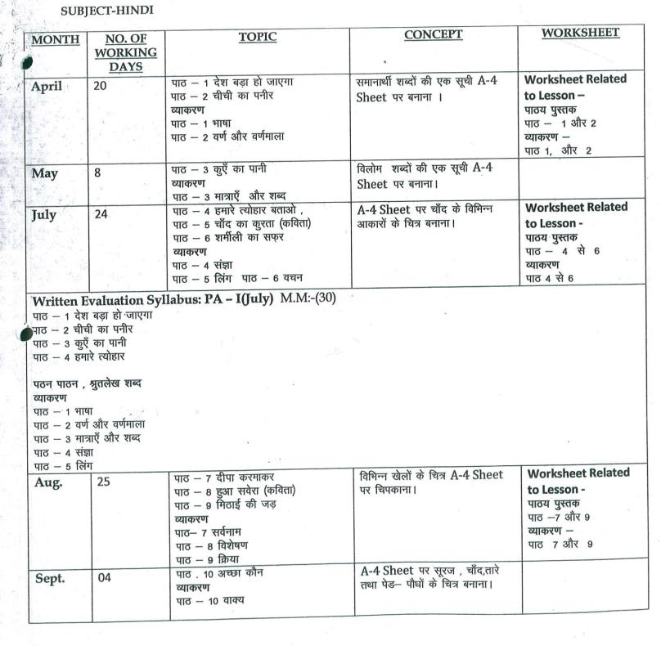
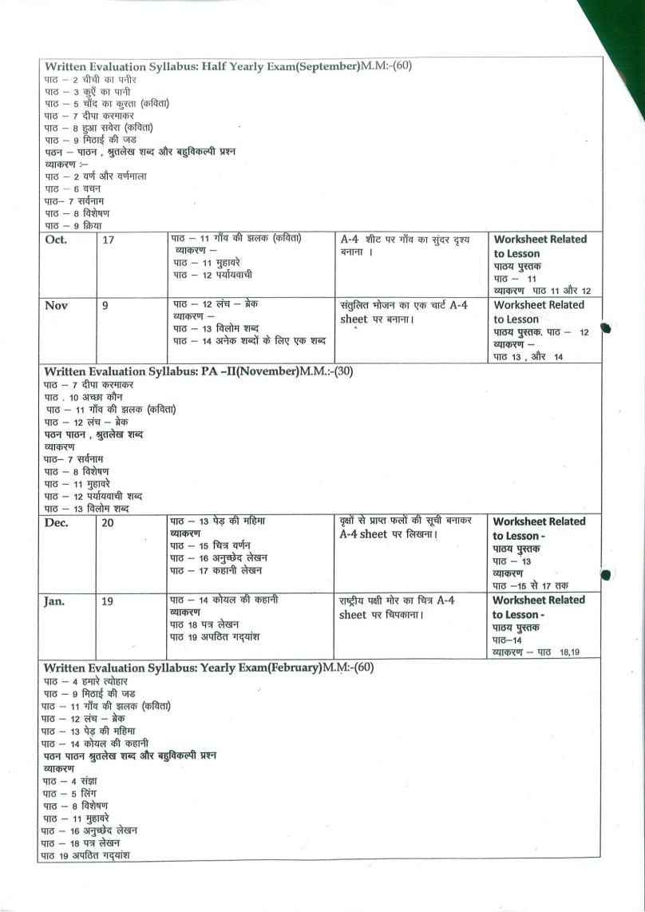

SUBJECT-MATH

MONTH | NO. OF WORKING DAYS | TOPIC | CONCEPT | ACTIVITY | WORKSHEET
Apr. | 18 | Ch-1 Revision  Ch-2 Numbers (Up to Ten Thousand)  Ch-4 Addition | - Numbers in expanded form, Place value & face value, skip counting & comparison of numbers  - Addition with carrying & without carrying | - Hopscotch  - Using Abacus and boxes for addition | Ch-2 & 4
May | 8 | Ch-4 Addition  (Continued) | - Subtraction with borrowing & without borrowing | Ch-5 Use of word problem & daily use item to make the concept easy | Ch-5
Jul. | 24 | Ch-3 Roman Numerals  Ch-5 Subtraction | - Introduction  - word problem on addition & subtraction | Write Date of birth of your family members using Roman Numerals(use tooth picks and paste on A4 sheet) | Ch-6
Written Evaluation Syllabus: PA-I(July) MM(30)
Ch-1 RevisionCh-2 Numbers (Up to Ten Thousand)
Ch-3 Roman NumeralsCh-4 Addition
Ch-5 Subtraction*Dodging tables 2 to 10
Aug. | 25 | Ch-6: Word Problems on Addition and Subtraction  Ch7:Multiplication  Ch-8 Division  Ch-10 Fraction | - Multiplication using repeated addition, carrying & tables.  - Introduction & word problem  - Concept of Numerator & denominator, fractions shading | - Spin wheel activity for multiplication  - Show fractions on cardboard using Origami sheets | Ch-7, 8, 10
Sep. | 4 | Ch-11 Measurement of length | - Devices to measure length, conversion, addition & subtraction of length | - Find out the length of any five objects in your classroom using a ruler and note down your findings on A4 sheet | Ch-11
Written Evaluation Syllabus: Half yearly Exam(September) MM(60)
Ch-4 Addition
Ch-6: Problems on Subtraction
Ch7:Multiplication
Ch-8 Division
Ch-10 Fraction
Ch-11 Measurement of length
*Dodging tables 2 to 15
Oct. | 17 | Ch-12 Measurement of weight  Ch-13 Measurement of Capacity | - Addition & subtraction of weights.  - Conversion & addition ,subtraction of capacity | Draw a measuring instrument for capacity. Take its cut-out and prepare a mobile | Ch-12, 13
Nov. | 9 | Ch-9 Money  Ch-14 Time | - Introduction of currency ,Addition & subtraction of money  - Reading of time from clock | - Virtual shopping using fake currency  - Make a clock using any landform as background | Ch-9,14
Written Evaluation Syllabus: PA-II(November) MM(30)
Ch-9 Money
Ch-12 Measurement of weight
Ch-13 Measurement of Capacity
Ch-14 Time
Dodging tables15 to 18
Dec. | 20 | Ch-15 Calendar  Ch-16 Geometry | *Concept related to calendar  *Different types of lines, shapes & points. | - Use calendar to teach the days & months  - Use shapes blocks & daily use items to identify the shapes. | Ch- 15, 16
Jan. | 19 | Ch-18 Pictograph | Drawing a pictograph, reading & interpreting of pictograph | Create a birthday chart of students with the help of related pictures & make the children read it. | Ch-18
Written Evaluation Syllabus: Final Exam(February)MM(60)
Ch-9 Money
Ch-12 Measurement of weight
Ch-13 Measurement of Capacity
Ch-14 Time
Ch-15 Calendar
Ch-16 Geometry
Ch-18 Pictograph
Dodging tables 2 to 20

SUBJECT-SCIENCE
MONTH | NO OF WORKING DAYS | TOPIC | CONCEPT | ACTIVITY | WOKSHEET
April | 18 | L-3 Housing and clothing  L-2 Keeping Safe  L-6 Living and non living things | 1.Pictures of different types of Houses  2.Real examples of different type of clothes  3. To enable the students to write their own answers with the help of creative writing  1. Showing first aid box to the children.  2. Discussion about safety measures with the help of pictures.  1.Real example of living and non living things | 1 .Collect pictures of different type of Houses on A-4 sheet and write few lines about it.  1. Make a model of traffic signal.(Activity on Page 27 in let’s create)  1.Collect the pictures of at least two living and two non living things whose name starts with the following letters  A,D,F,H,M,S,T.(Do it on A-4 Sheet) | Worksheet based on L-2 and 3
May | 8 | L-7 Parts of plant | 1.Showing a real plant in the class | 1. Draw parts of plant in the notebook.  2. Collect seeds of different colours and sizes. Take A4 sheet and make any pattern of drawing(Refer page 70 ,activity -1 in let’s create) | Worksheet based on ch-6 and 7
July | 24 | L-1 Eating habit of Animals  L-8 Birds | 1.Pictures of different animals with their teeth  1. Showing pictures of different types of birds and their feathers, Beak and claws | 1. Draw pictures of food chain in notebook.  2. Paste pictures of two each on A4 sheet-Herbivores,carnivores,omnivores.  1.Collect and paste pictures of two each:-Perching birds, Scratching birds, Climbing birds, Wading birds by making columns on chart paper. | Recapitulation worksheet for PA-1
Written Evaluation Syllabus: PA –I(July) MM(40)
L-1 Eating habit of Animals
L-2 Keeping Safe
L-3 Housing and clothing
L-6 Living and non living things
L-7 Parts of plant
(L-1 Only book ex. and define)
Aug. | 25 | L-9 Our body  L- 5, Solid, liquids and gases | 1.Visiting lab and showing different type of human system  1. Showing real example of solid, liquids and gases. | 1.Make a model of respiratory system using cardboard and chart paper(refer page 87 in book)  Write at least 5 examples each for solid, liquids and gases found at your home on A4 sheet | Recapitulation worksheet for Half yearly
Sep. | 4 | Revision for Half Yearly Exams
Written Evaluation Syllabus: Half Yearly Exam(September) MM(60)
L-1 Eating habit of Animals
L-2 Keeping Safe
L-3 Housing and clothing
L-5 Solid, liquids and gases
L-6 Living and non-living things
L-7 Parts of plant
L-8 Birds
L-9 Our body
Oct. | 17 | L-4, Soil  L-12, Air, water & weather | 1. Showing different types of soil.  1. Showing picture of water cycle and different seasons. | 1. Making of an animal/doll using clay.  2. Creative writing - Which of four seasons is your favourite and why? | Worksheet based on L-4,12
Nov. | 09 | L-10, Measurement | 1. Showing different objects related to measurement. | Measure the height and weight of your family members and find out the difference. | Recapitulation Worksheet for PA-2
Written Evaluation Syllabus: PA II(November) MM(40)
L-2 Keeping Safe
L-4, Soil
L-9 Our body
L-10, Measurement
L-12, Air, water & weather
Dec. | 20 | L-11,Light,Sound and Force  L-13, The Sun, Moon and Star | 1. Visiting the playground to understand the concept of shadow.  2. Showing real objects to clear the concept of force.  1. Showing pictures of phases of Moon and Solar System. | Collect pictures of 5 luminous and 5 non luminous objects and paste them on A4 sheet.  Make different constellations using sticker of stars on A4 sheet. | Worksheet based on L-11,13
Jan. | 19 | L-14,Our Earth | 1. Showing rotation & Revolution of the Earth through a globe.  2. To tell them about recycle and reuse | Make a pen stand using old cans.The cans may be either painted or covered with cloth,or paper. Decorate your pen stand.
Feb. | 6 | Revision |  |  | Recapitulation worksheet for final exam.
Written Evaluation Syllabus: Yearly Exam(February) MM(60)
L-4, Soil
L-5 Solid, liquids and gases
L-8 Birds
L-10, Measurement
L-11,Light,Sound and Force
L-12, Air, water & weather

SUBJECT-SOCIAL STUDIES
MONTH | NO. OF WORKING DAYS |  | TOPIC | CONCEPT | ACTIVITY | WORKSHEET
April | 18 |  | L- 1. The Earth and its Neighbors  L-2. The water we drink | L-1.Showing the Globe and solar system  L-2 Picture of water cycle. | L-1. Draw different constellations  L-2. Draw a well labeled diagram of water cycle. | Given at the back of the Chapter
May | 8 |  | L-3. Our Environment | L-3. Showing flash cards of Causes and Kinds of Pollution | L-3. Find out four pollutants from the given grid. | Given at the back of the Chapter
July | 24 |  | L-4.Political Division of India  L-5. Major Landforms of India  L-6. Indian Food | L-4. States and Union Territories of India  L-5. Discussion on geographical regions of India.  L-6. Showing pictures of various pulses & food grains of India | L-4. Map Work  L-5. Map Work  L-6. Draw any two vegetables and fruits using waste materials. | Given at the back of the Chapter
Written Evaluation Syllabus: PA-I(July) MM:40
L- 1. The Earth and its Neighbors
L-2. The water we drink
L-3. Our Environment
L-4.Political Division of India
Aug. | 25 |  | L-7. Indian Dresses  L-8. Indian Festivals  L-10. Delhi : The Capital of India | L-7. Showing flash cards of traditional dresses of India  L-8. Discussion on various Religious, Harvest and National festivals of India.  L-10.Showing pictures of famous places of Interest and worship. | L-7. Collect pictures of traditional dresses and make a Collage  L-8. Matching the names of the festivals (flash cards) with the details  L-10.Make a collage of places of Worship in New Delhi. | Given at the back of the
Sept. | 4 |  | Revision |  |  | Worksheet based on above chapters.
Written Evaluation Syllabus: Half Yearly Exam (September) MM:-60
L- 1. The Earth and its Neighbors L-2. The water we drink L-3. Our Environment L-4.Political Division of India L-5. Major Landforms of India L-6. Indian Food L-7. Indian Dresses L-8. Indian Festivals L-10. Delhi : The Capital of India
Oct. | 17 |  | L-9. Our Occupations  L-11. Mumbai : The Commercial Capital of India  L-12.Kolkata : The City of Durga Puja | L-9. Sharing the knowledge on various methodologies for Agriculture, Cattle Rearing & Poultry Farming etc.  L-11. Discussion on Location, Climate, Places of Interest and Worship, Transport.  L-12. Discussion on the festival of Durga Puja. | L-9.Prepare a list of different occupations you see around yourself.  L-11.Collect pictures of Bollywood actors in A4 sheet.  L-12. Make a chart on”DurgaPuja”and write 5 lines on it. | Given at the back of the Chapter
Nov. | 9 |  | L-13. Chennai: The city of Beautiful Temples  L-14. Other Famous cities of India  L-15. People who help us | L-13. Location, Climate, Places of Interest and Worship, Transport.  L-14. Discussion on the chapter.  L-15. Showing pictures | L-13. Make a collage on South Indian food.  L-14.Map work  L-15.Find out the names of some people who help us in our day to day life. | Given at the back of the Chapter
Written Evaluation Syllabus: PA-II(November) MM:-40
L-11. Mumbai : The Commercial Capital of India L-12.Kolkata : The City of Durga Puja
L-13. Chennai: The city of Beautiful Temples L-14. Other Famous cities of India
L-15. People who help us
Dec. |  | 20 | L-16. How we Travel  L-17. How we Communicate  L-18. Our Local Bodies | L-16. Land Transport, Water transport, Air transport, Animal transport etc.  L-17. Showing pictures on evolution of Postal services. L18. Gram Panchayat, functions of Municipal Corporation and Gram Panchayat etc. | L-16. Draw the various public transports you use for daily commute.  L-17.Paste pictures of postal communication in your notebook  L-18. Perform a short skit by Electing your Class Panchayat. | Given at the back of the Chapter
Jan. |  | 19 | L-19.Our Government  L-20.Inventions of Early Man | L-19.Types of Government- State and Central  L-20. Showing the Invention of Wheel by early man with the help of pictures. | L-19. Paste pictures of first 5 Prime Ministers of India on an A-4 sheet and write few lines about them.  L-20. Create a brochure on Invention of Wheels by Early Man. | Given at the back of the Chapter
Written Evaluation Syllabus: Yearly Exam(February) MM:-60
L-11. Mumbai : The Commercial Capital of India L-12.Kolkata : The City of Durga Puja
L-13. Chennai: The city of Beautiful Temples L-15. People who help us
L-16. How we Travel L-17. How we Communicate
L-18. Our Local Bodies L-19.Our Government L-20.Inventions of Early Man

SUBJECT-COMPUTER
MONTH | NO. OF WORKING DAYS | CONTENT |  |  | ACTIVITY | PRACTICAL | WORKSHEET
April | 18 | Ch – 1 : Knowing Computers  Ch – 5 : Introduction to Tux paint(Reading) |  |  | * Draw computer in notebook and label it also. | *Tux Paint | Ch-1 ,5
May | 8 | Ch – 5 : Introduction to Tux paint(Exercise) |  |  | Draw mascot of Tux Paint in notebook.
July | 24 | Ch – 6 : Fun with Tux Paint |  |  | *Draw different tools of Tux Paint in notebook. | *Tux Paint | Ch – 6
Written Evaluation Syllabus: PA-I(July) MM:20
Ch – 1 : Knowing Computers
Ch – 5 : Introduction to Tux paint
Practical : Tux paint
Aug. | 25 | Ch- 2 : Hardware and Software  Ch – 4 : Introduction to MS-Windows |  |  | *Draw any two hardware and software pictures in notebook.  * Draw logos of different types of operating system in notebook | *Tux Paint | Ch – 2,4
Sep. | 4 | Revision + Half Yearly
Written Evaluation Syllabus: Half Yearly Exam (September) MM:-30
Ch- 2 : Hardware and Software
Ch – 4 : Introduction to MS-Windows
Ch – 6 : Fun with Tux Paint
Practical: Tux paint
Oct. | 17 | Ch-7: Introduction to Ms –Word 2016  Ch- 8: Formatting Text with Ms- word 2016 ( Reading) | *Draw MS-Word 2016 window screen in notebook. |  |  | * MS- Word | Ch 7,8
Nov. | 9 | Ch- 8: Formatting Text with Ms- word 2016 (Exercise) | *Draw Font Family box of MS-Word in notebook.
Written Evaluation Syllabus: PA-II(November) MM:-20
Ch-7: Introduction to Ms –Word 2016
Ch- 8: Formatting Text with Ms- word 2016
Practical : MS-Word
Dec. | 20 | Ch-3: Input – Process –Output  Ch – 9 : Introduction to Scratch | *Paste input, output and storage devices in notebook.  * Draw scratch mascot in notebook. |  |  | *Scratch | Ch 3 ,9
Jan. | 19 | Ch – 10 :Fun With Scratch | * Draw different tools of Scratch in notebook. |  |  |  | Ch 10
Feb. | 6 | Revision + YEARLY EXAM
Written Evaluation Syllabus: Yearly Exam(February)MM:-30
Ch-3: Input – Process –Output
Ch – 9 : Introduction to Scratch
Ch – 10 :Fun With Scratch
Practical: Scratch

SUBJECT – G.K.

MONTH | NO. OF WORKING DAYS | CONTENT
April | 18 | Page no. 3 to Page no. 11  Page no 67and Page no.68
May | 8 | Page no. 12 to Page no. 15 and  page no 71
July | 24 | Page no. 16 to Page no.20  Revision
Written Evaluation Syllabus: PA-1(July) M.M.-20
Page no. 3 to Page no 15
Page no. 67 and Page no 68
Aug. | 25 | Page no. 21 to Page no. 32  Current Affairs
Sept. | 4 | Revision
Written Evaluation Syllabus: Half Yearly Exam(September) M.M.:-30
Page no. 16 to Page no. 32 and Page no 71
Current Affairs
Oct. | 17 | Page no. 33 to Page no.44
Nov. | 9 | Page no. 45 , 46  Revision
Written Evaluation Syllabus: PA-II(November) M.M.-20
Page no. 33 to Page no. 46
Dec. | 20 | Page no. 47 to Page no. 60
Jan. | 19 | Page no. 61 to Page no. 66,  Page no 69,70 and Page no. 72  Current Affairs , Revision
Feb. | 6 | Revision
Written Evaluation Syllabus: Yearly Exam(February) M.M.-30
Page no. 47 to Page no. 66
page no 69, 70 and Page no. 72
Current Affairs

SUBJECT-DRAWING & ART/CRAFT
MONTH | NO. OF WORKING DAYS | PAGES OF ART BOOK | ACTIVITY
April | 18 | 3,4,18,30 | Tree Cotton Impression 18  Bird – Tissue Paper 30
May | 8 | 5, 6, 19, 31 | Puppet – Model 31
July | 24 | 7,8,20,21,32,34 | Tree house 18  Umbrella – Air Blow 21  Bunny – Ice creamstick 32  Dolphin – Clay Modeling 34
Aug. | 25 | 9, 10,22,23,35,36 | Tree-strencil 22  Elephant – Paper impression 23  Butterfly –Icecream spoon 35
Sep. | 4 | Revision
Written Evaluation Syllabus: Half-Yearly Exam(September)
Page no. 3 to 10
Page no 18 to 23
Page no. 30 to 37
Oct. | 17 | 12,13,25,29,38 | Diya – Toothpick activity 25  Rangoli Wood powder pasting  Village – sand paper activity 38
Nov. | 9 | 14,15,24,26,39 | Swan – pencil shading 26  Newspaper flower 39
Dec. | 20 | 11, 16, 27, 40, 41 | Snowman – Icecream stick 40  Tribal face – woolstring pasting 41
Jan. | 19 | 17,28,42 | Fish – Paper quiling 42
Feb. | 6 | revision
Written Evaluation Syllabus: Yearly Exam(February)
Page no. 11 to 17
Page no. 24 to 2
Page no. 29 and page no. 38 to 42

SUBJECT-DANCE
Month | Number of Working Days | Topic
April | 18 | Foot, Shoulders, Hands, Neck, Waist movements
May | 8 | Foot, Shoulders, Hands, Neck, Waist movements
July | 24 | Aerobics and body stretching exercises  Body balancing movements
Aug. | 25 | Aerobics and body stretching exercises  Body balancing movements (Janmastmi Celebration)
Sep. | 4 | Free style dancing (Dussehra celebration)
Oct. | 17 | Free style dancing (Dussehra celebration)
Nov. | 9 | Western Dance (Christmas Celebration)
Dec. | 20 | Western Dance (Christmas Celebration)
Jan. | 19 | Patriotic dance (Republic day celebration)
Feb. | 6 | Patriotic dance (Republic day celebration)
- Presentation of houses activity

